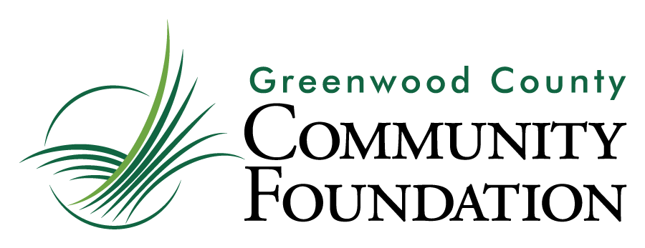

Grant Application

This is a Word Document; should you need additional space to complete a question, you may expand the appropriate text box to meet your needs. Please contact the Foundation at 864.223.1524 or staff@greenwoodcf.org with any questions.
Contact Information
Organization’s Legal Name
Executive Director’s Name
Email Address
Office Phone
Program/Project
Coordinator’s Name
Email Address
Office Phone
Organization’s Street Address
City ST ZIP Code
(If different) Mailing Address
City ST ZIP Code
EIN (Fed Tax ID Number)
Grant Amount Requested

Purpose of the Grant Requested
In a few sentences, describe the program or project to which the grant will be applied. Is this a new or existing program or project?

Program or Project Details
Describe the problem or opportunity the program or project addresses.

Summarize the program or project’s overall plan of activity to address the problem or opportunity. How is this program or project related to GCCF’s focus for this grant cycle?

What steps has your organization taken to assess the population affected by the problem or opportunity? How many people in Greenwood County are affected by this problem or opportunity?

What other organizations in Greenwood County address this problem or opportunity? How has your organization collaborated with these organizations? Explain what differentiates your program or project.

Identify the outcomes the organization is committed to achieving this year with this program or project.
What measures will be used to demonstrate the impact of this program or project on the population served?

Organizational Information

What is the Mission Statement of your organization?

Describe current, key programs and services of the organization.

Please provide a brief history of your organization’s work in Greenwood County.

Do your Board and staff reflect the demographics of Greenwood County? List the names (and affiliations)
of all members currently on the organization’s Board of Directors.

The following questions are to assist GCCF in its service to local organizations
and do not affect the grant evaluation process.

What is your organization’s strategy for long-term funding?

How may the Greenwood County Community Foundation advise your organization in planning for the
future through the creation or transfer of an endowed Agency Fund?

Program or Project Budget

Indicate expenses for this program or project.

Program or Project Expenses | Total Funds Requested from GCCF in this Application  ($5,000 maximum) | Total Expenses  for this Program or Project
Administrative expenses | $ | $
Equipment | $ | $
Fees (specify) | $ | $
 | $ | $
Materials and/or supplies | $ | $
Operating expenses | $ | $
Publicity | $ | $
Salaries or stipends (specify)
 | $ | $
 | $ | $
Services (specify)
 | $ | $
 | $ | $
Other (specify)
 | $ | $
 | $ | $
TOTALS | $ | $

Indicate sources of funding for this program or project.

Program or Project Funding | Committed  (Funds that have been awarded or designated for this program or project) | Pending or Projected  (Funds that have not yet been confirmed for this program or project)
GCCF | $ | $
Fundraising | $ | $
In-kind support | $ | $
Organizational budget | $ | $
Organizational donors | $ | $
Participation fees, if any | $ | $
Other grantors (specify)
 | $ | $
 | $ | $
 | $ | $
Other (specify)
 | $ | $
TOTALS | $ | $
Please attach the following as separate documents (send electronically to staff@greenwoodcf.org.):
Organizational budget
Most recent financial statement, dated within past 6 months. (Please do not submit a full audit.)
Proof of IRS tax-exempt status
Non-discrimination statement adopted by the Board of Directors
Annual Report, if available

Agreement and Signature
By submitting this application, I affirm that the facts set forth in it are true and complete.

Name (printed)
Signature
Date

Thank you for your grant application submission!
Greenwood County Community Foundation
110 Phoenix Street
Greenwood, SC 29646
864.223.1524
Contact: staff@greenwoodcf.org

Rev.11.11.2020

